**How to print the daily Family Literacy office schedule.**

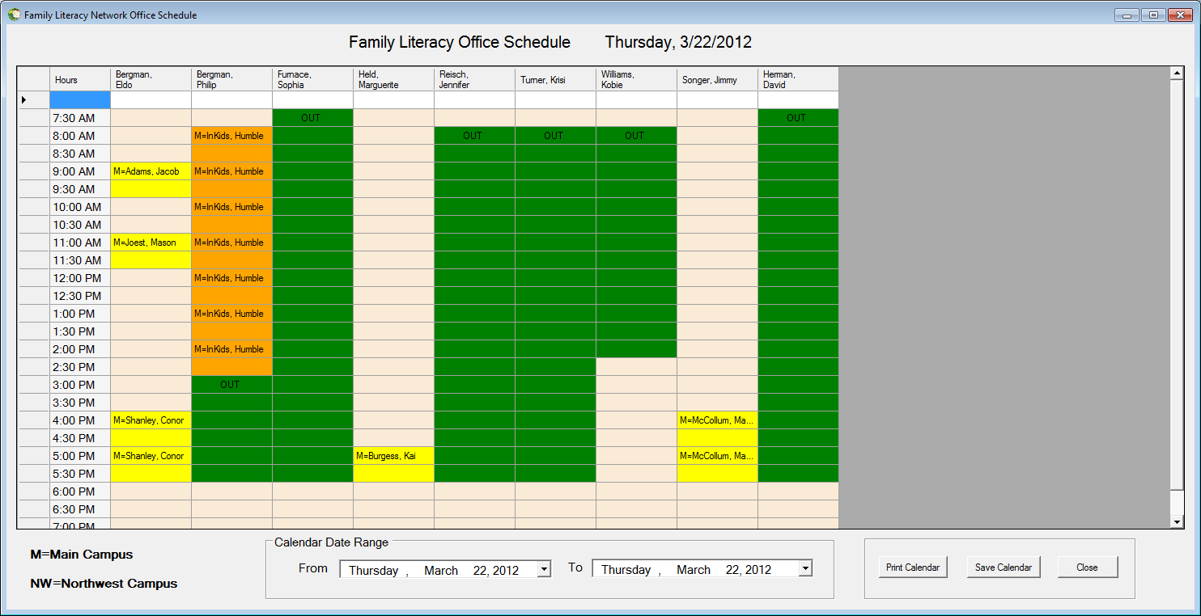

**Campus Key Print office Schedules within Button Controls**

**the specified date range for printing, saving,**

**and exiting the screen**

**The user will have the capability to Print Office schedules for a single day or multiple days.**

1. **Select a “From” date**

**Select the date which you would like to start printing from.**

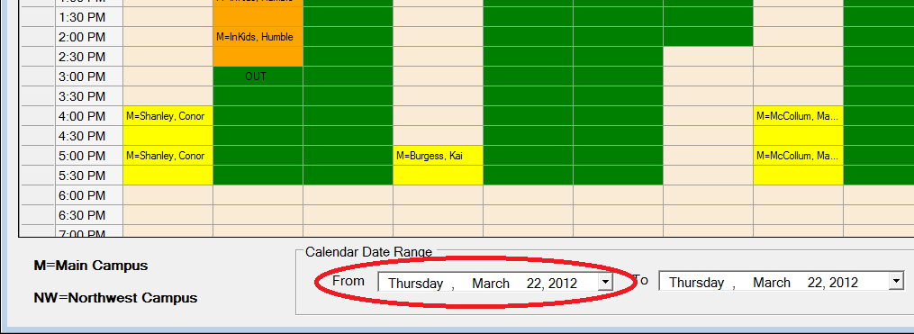

1. **Select a “To” Date**

**Select the final date which you would like to stop printing at.**

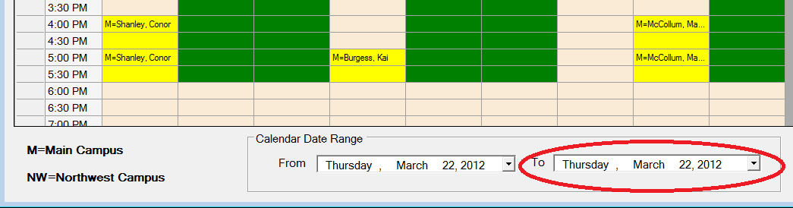

1. **Next there are two options:**
2. **“Print” the schedules or**
3. **“Save” the schedules to your hard drive.**
4. **Click the “Print Calendar” button to print the Schedules**

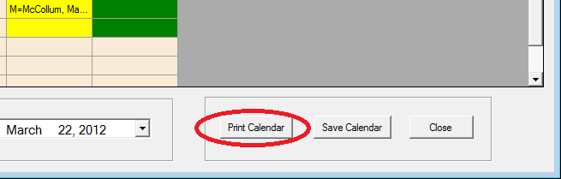

1. **Select you’re your printer and then click print.**
2. **Select Landscape under “Preferences”**

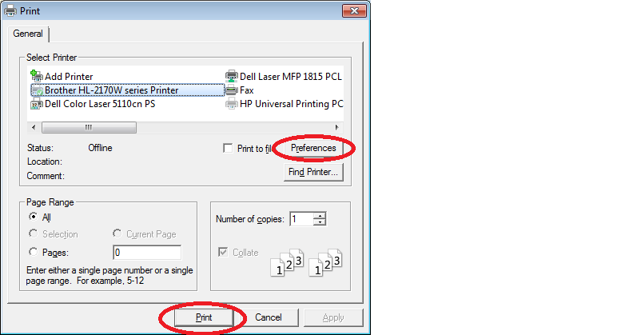

1. **Saving the schedules to the Hard drive**
2. **Click on the “Save Calendar” button**

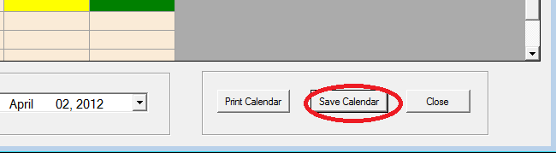

1. **Find you’re your printer and then click print.**

